Delta Electronics (Thailand) Wins Thailand’s Top Corporate Brand Values Award

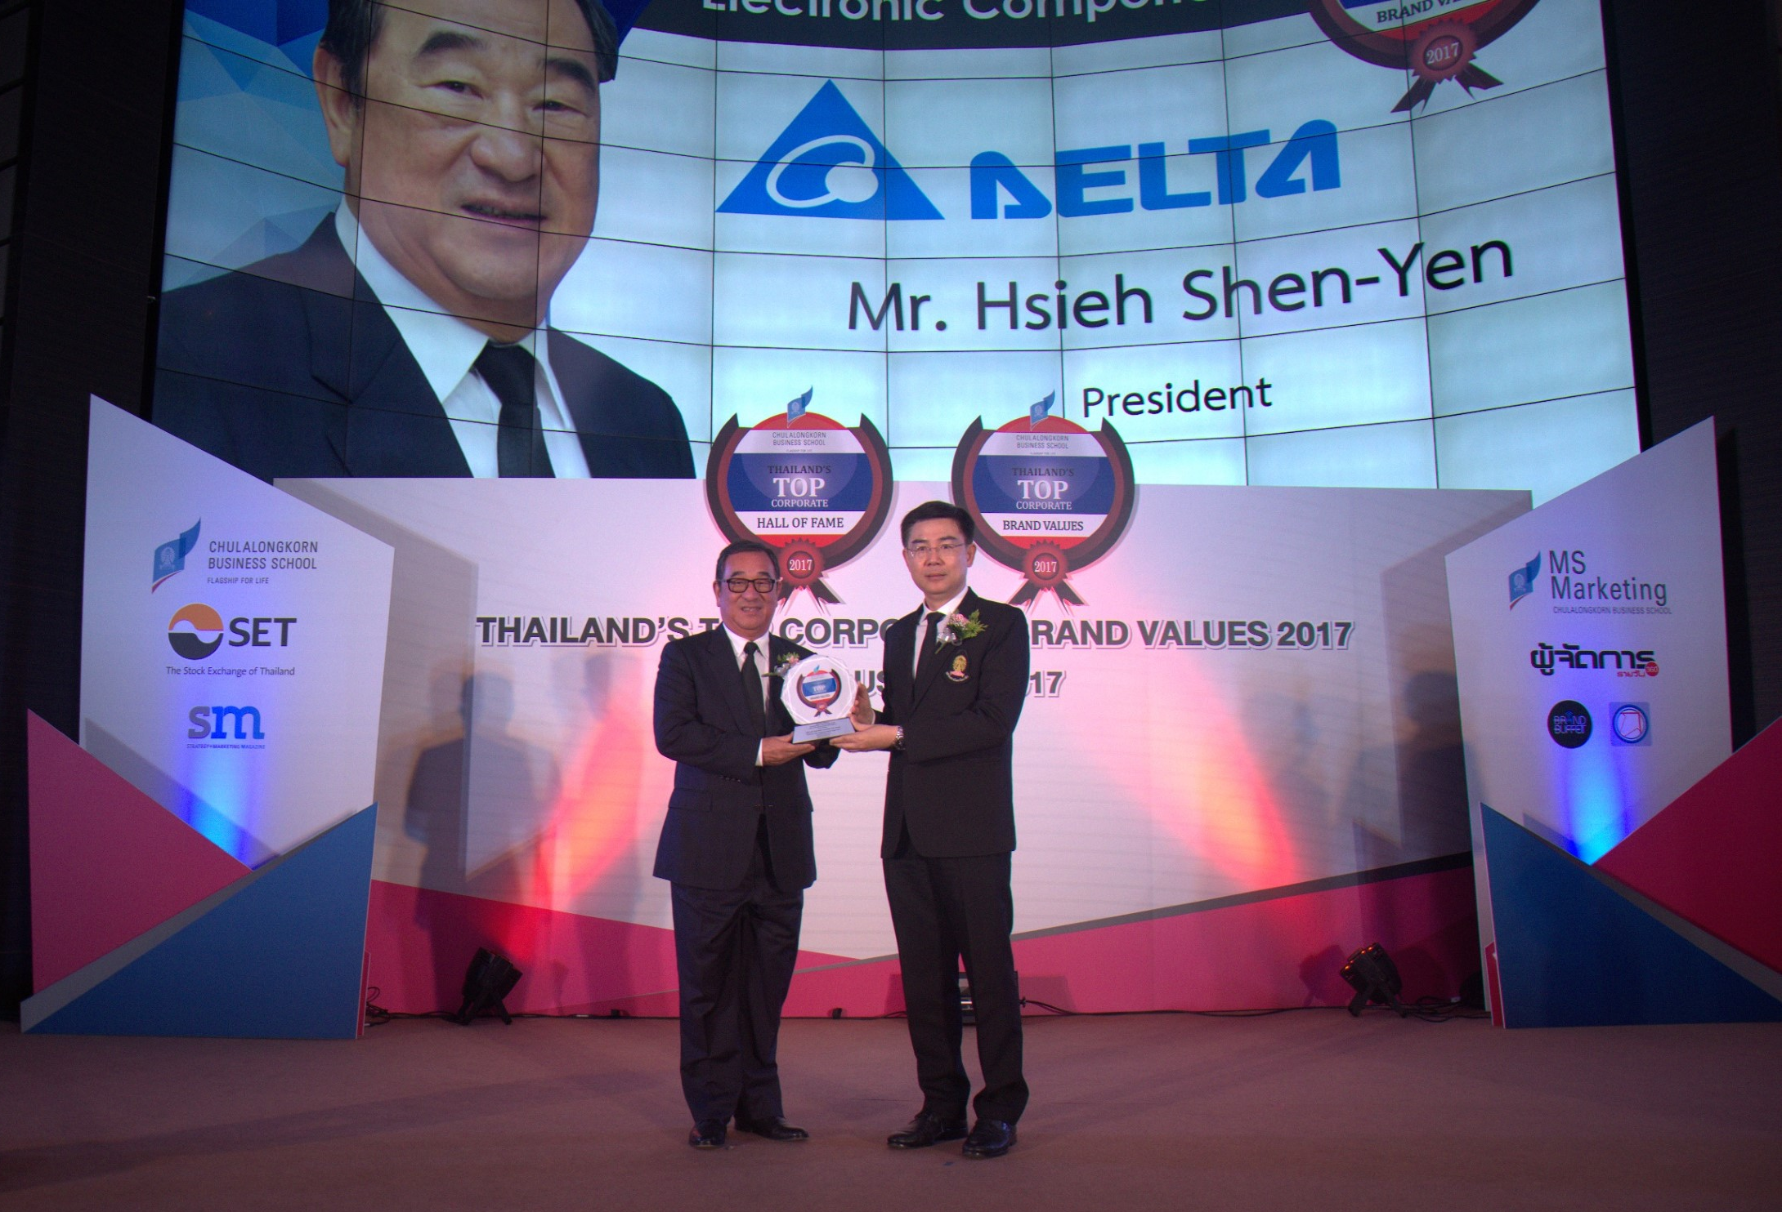

Mr. Hsieh Shen-yen (left) receiving Thailand’s Top Corporate Brand Values 2017 Award from
Professor Bundhit Eua-arporn, Dean of Chulalongkorn University

Bangkok, Thailand, August 16, 2017- Delta Electronics (Thailand) PCL. has been honored for the third consecutive year at the Thailand’s Top Corporate Brand values Awards. This year, the company was awarded for achieving the highest corporate brand value in Thailand worth 50,381 million baht. Professor Bundhit Eua-arporn, Dean of Chulalongkorn University, presented the Thailand’s Top Corporate Brand Values 2017 Award to Mr. Hsieh Shen-yen, President of Delta, at the Sukree Kaewcharoen Auditorium in Stock Exchange of Thailand.

The award is jointly organized by the Faculty of Commerce and Accountancy at Chulalongkorn University and the Stock Exchange of Thailand in recognition of Thai organizations that had achieved outstanding corporate brand value in every industry. In addition, the award aims to create awareness for corporate brand development which is an important factor in driving a business toward a sustainable future. Delta has been recognized in the Electronic Components industry for three consecutive years since 2014 starting from the Rising Star award. From 2016 to 2017, Delta had grown its corporate brand value by 37% with its business strategy focusing on Power Electronics, Automation and Infrastructure. The award has been applying the "CBS Valuation" (Corporate Brand Success Valuation) methodology since its inauguration. CBS is an integrated mathematical formula based on marketing, finance, and accounting concepts.

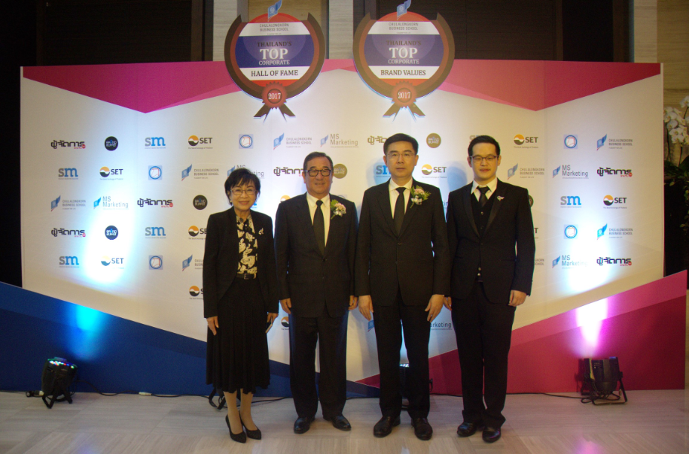
Prof. Guntalee Ruenrom, a lecturer at the Department of Marketing, Faculty of Commerce and Accountancy, Chulalongkorn University developed CBS valuation

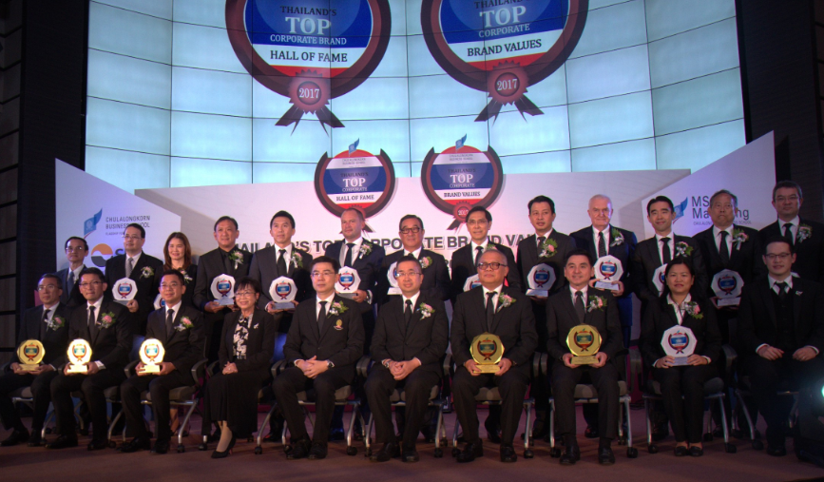
Group photo of organizations with top corporate brand value in every industry
###

About Delta Electronics (Thailand) Public Company Limited
Delta Thailand, founded in 1990, is one of the leading producers in the world for power and thermal management solutions. The company is also a major regional player in several product segments including industrial automation, displays, and networking. Its mission statement, “To provide innovative, clean and energy-efficient solutions for a better tomorrow,” focuses on addressing key environmental issues such as global climate change. As an energy-saving solutions provider with core competencies in power electronics and innovative research and development, Delta's business categories include Power Electronics, Automation, and Infrastructure. Delta Thailand’s global presence is supported by its sales offices in key regions around the world; manufacturing facilities in India, Slovakia and Thailand; and ten R&D centers located in India, Thailand and other countries.

Delta Thailand has been widely recognized in the region and domestically as an industry leader. Some awards won included the prestigious ASEAN Business Award, Stock Exchange of Thailand Award for Outstanding Performing Company and the coveted Prime Minister’s Best Industry Award.

For detailed information about Delta Thailand, please visit: www.Deltathailand.com

Tel: +66 (0)2709 2800 ext. 6303, 6381
Email: det.marketing@deltaww.com

